

*Lab 5: Speed of Sound and Light*

* Name : *Prescott Rynewicz*
* UID : *504288967*
* Lab Partners: Ashkay, Karina
* Date : *4/20/2017, Wednesday 11AM*

Table of Contents

Introduction 3

Experimental Results 4

Method 1: Traveling Sound Waves 4

Method 2: Standing Sound Waves 6

Analysis 9

Method 2 9

Method 2 9

Summary 11

# Introduction

The purpose of this lab is to experimentally view the properties of traveling light and sound waves. Light and sound travel through using very different methods and at very different speeds, but both present properties of waves that we can observe and record. In this lab, sound waves will be focused on, and their speed. Two different methods will be used to calculate the speed of sound waves, which will be compared to the accepted speed of sound at sea level.

# Experimental Results

In this lab, data was collected to measure the speed of sound using two different methods. These methods are outline below

## Method 1: Traveling Sound Waves

In this method, a precise speaker driven by a frequency wave driver, a microphone and precise distance measurement scale is used. The figure below shows the experimental setup.

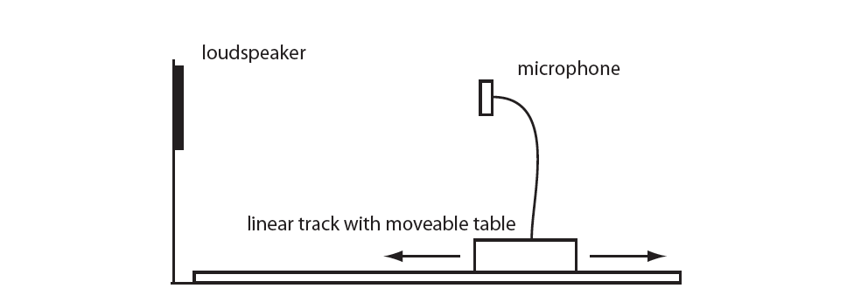

*Figure 1: Speed of Sound, Method 1 Experimental Setup*

In order to calculate the speed of sound, 5 different frequency are chosen, and sent into the microphone one at a time. This signal that is sent to the microphone is split and also sent to an oscilloscope. The output from the microphone reading this signal is also sent to the oscilloscope. For each frequency, the amplitude peaks for the driven and received signals are aligned on the oscilloscope, by moving the position of the microphone. Once aligned, the microphone is then moved again in either direction until the peaks align. This is exactly ½ wavelength of the sound. Now that the wavelength, and frequency of the wave is known, we are able to calculate the speed of the wave using

$$Speed=f*λ$$

The average values from all 5 calculations are used to determine the final result, with uncertainty.

*Figure 2: Dispersion Relation for Traveling Sound Waves Obtained By Phase Shifts.*

*The X-Axis represents the Wavevector k, which is equal to $\frac{2π}{λ}$* *. The Y-Axis represents the angular frequency of the driven wave, equal to $2πf$.*

This plot, and its results will be used in the analysis section to calculate the speed of sound.

## Method 2: Standing Sound Waves

For this method, the microphone and speaker are again used, but now a reflective metal plate attached to a wheel equipped with a 10 turn potentiometer is also used. The experimental setup for this method is shown below.

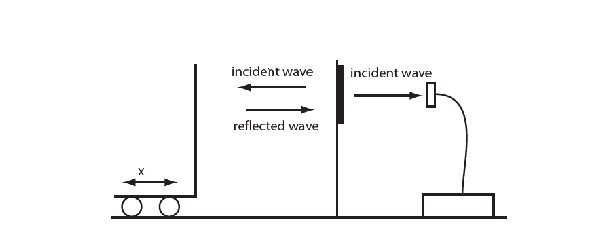

*Figure 3: Speed of Sound, Method 2 Experimental Setup*

For this method, instead of using the oscilloscope to collect data, the MyDAQ is used to collect data. The MyDAQ records both the voltage position of the potentiometer and the output voltage from the microphone.

First, the potentiometer must be calibrated. This is done by recording the voltage at a series of equally spaced points. The results and plotted, and the slope of the line is the conversion factor between voltage to position for the potentiometer. This calibration plot is shown below.

*Figure 4: Potentiometer Calibration Plot.*

*The X-Axis in this plot is the absolute position of the reflective plate, measured in centimeters. The Y-Axis is the Voltage output from the potentiometer.*

The results of the potentiometer calibration are shown in the analysis section.

The main goal of this method is to find the wavelength of sound. A Frequency is chosen to be used from the wave driver, in this case

$$f=10 kHz$$

While driving this frequency through the speaker, and simultaneously collecting data for the potentiometer voltage, and the microphone voltage, by very slowly moving the reflective plate attached to the potentiometer towards the speaker, changes will occur in the amplitude peaks for the microphone output. This changes in amplitude peaks vs. the position of the reflective plate can then be used to find the distance between maximum amplitudes, and find the wavelength. A plot showing reflector position vs. Microphone voltage, and the wavelength values found are shown below.

*Figure 5: Method 2 Wavelength Plot.*

*The X-Axis shows the position of the reflective plate in cm, and the Y-Axis is the voltage from the microphone output.*

|  |
| --- |
| Half Wavelength (cm) |
| 0.00013 |
| 0.00016 |
| 0.00016 |
| 0.00014 |
| 0.00014 |

*Table 1: Wavelength Results from Lab Method 2.*

# Analysis

This section focuses on the analysis of the experimental data. We will be calculating and discussing the points below.

1. The Speed of Sound from data collected in method 1.
2. The Speed of Sound from data collected in method 2.
3. Comparing these results to the accepted values for speed of sound at sea level.

## Method 1

To calculate the speed of sound in method 1, we simply need to find the slope of the line from figure 2. This is done using the regression tool, which also calculates the uncertainty in our value. The results are shown below.

$$v_{sound}=400±32\frac{m}{s}$$

This calculated value is close to the accepted value for speed of sound at sea level, but even within the bounds of uncertainty, it still does not align with the accepted value. This is most likely due to errors in lab equipment. When performing the lab, large amounts of drift would occur on the time scale for the microphone output, making it difficult to produce accurate results for the wavelength values.

## Method 2

To calculate the speed of sound in method 2, the average values from the experimentally determined wavelength are used with the driven frequency to calculate the speed of sound. The average wavelength with uncertainty is shown below

$$λ_{avg}= .00029± 0.00002$$

$$Standard Deviation=1.31E-5$$

The uncertainty for this value is determined by finding the largest difference between the average wavelength value, and the experimental wavelength values. The standard deviation is found by using the excel standard deviation tool. Using this value, and the driven frequency of 10kHz, we find the speed of sound to be

$$v_{sound}=292±7\frac{m}{s}$$

The uncertainty for this value is found using the equation below, which applies to all formulas whose terms are independent of each other, and are all products.

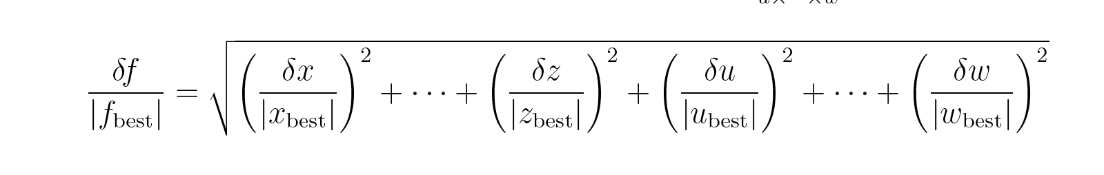

This value for the speed of sound also does not align with the accepted value for the speed of sound. Both this value and the value from method 1 differ by about 30-40 meters per second or about 9-12% error. As stated previously, this is most likely due to faulty test equipment and lack of human precision during the experiment. Particularly in method 2, the wheel connected to the potentiometer was very slick, and would slip frequently while in use, which would provide inconsistent data, and cause errors.

# Summary

In conclusion, the experimental results from this lab do not align with the accepted speed of sound. The average error between the two experiments is 10.5% error from the accepted value. This error is most likely due to quality of the lab equipment. In the first experiment (method 1), the oscilloscopes experienced significant drift in the position domain, which is critical to that method. The results were also screwed by background noise and the fact that multiple experiments using sound were conducted in the same classroom. The second experiment found error in using low quality potentiometers and moving wheels attached to the potentiometers, that could easily slip along the table top surface. Overall, the experiment provides insight into the nature of waves, but does not align with current accepted values for the speed of sound.